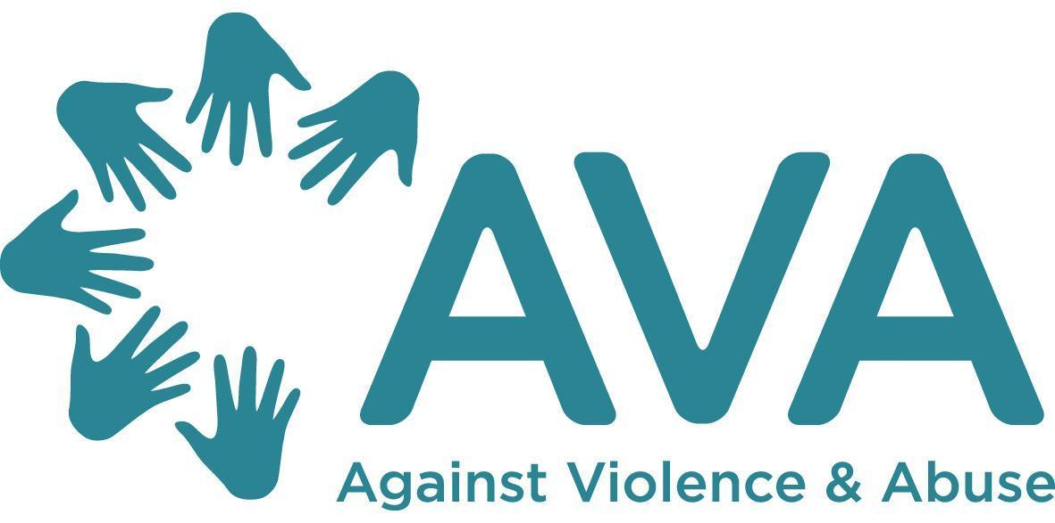

Equalities Monitoring Information
Finance and Administration Officer
Eva Kestner
36 hours per week
AVA wishes to monitor the effectiveness of its Equal Opportunities Policy and ensure that no direct or indirect discrimination is taking place. In order to help us do this we would like you to complete this form. This form will be detached from your application form and will not be used to influence the selection process in any way.
Please choose one option from each of the sections listed below and then tick or place an X in the appropriate box. If you prefer to leave any questions blank then please do so.
A. Age
Under 16
16 - 24
25 - 34
35 - 44
45 - 54
55 - 64
65+

B. Disability
The Equality Act 2010 defines a disabled person as someone who has a physical or mental impairment, which has a substantial and long term adverse effect on their ability to carry out normal day-to-day activities.
Do you consider yourself to have a disability according to the terms given in the Equality Act 2010?
Yes
No

C. Sex and Gender identity
Please describe your sex.
Male
Female
Prefer not to say

Please describe your gender identity.
Male
Female
Non-binary

D. Sexual orientation
Bisexual
Gay man
Gay woman
Lesbian
Heterosexual
Other (please specify)

E. Ethnic group
Asian, Asian British, Asian English, Asian Scottish, or Asian Welsh
Bangladeshi
Indian
Pakistani
Any other Asian background (specify if you wish)
Black, Black British, Black English, Black Scottish, or Black Welsh
African
Caribbean
Any other Black background (specify if you wish)
Chinese, Chinese British, Chinese English, Chinese Scottish, or Chinese Welsh, or other ethnic group
Chinese
Any other ethnic background (specify if you wish)
Mixed
White and Asian
White and Black African
White and Black Caribbean
White and Chinese
Any other Mixed background (specify if you wish)
White
British
English
Irish
Scottish
Welsh
Any other White background (please specify)

F. Religion or belief
No religion
Baha’i
Buddhist
Christian
Hindu
Jain
Jewish
Muslim
Sikh
Any other religion or belief (please specify)

