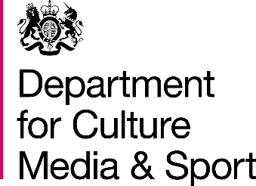
Funded by:

In Safe Hands
FAQs

Frequently Asked Questions

What is In Safe Hands?
AVA and partners have been funded by the Department for Culture, Media and Sport through the Tampon Tax fund to build and test a trauma informed kite mark for specialist VAWG services.

How long is the project funded?
We start in January ‘22 and run until 21st March 2023.

Where can pilot sites work?
Grants are invited from organisations across England.

Who are the steering group for this work?
There are six project partners, West Mercia Women’s Aid, Suffolk Rape Crisis, Chyan, One25, Icena, Women’s Aid Federation of Northern Ireland, who will contribute their extensive knowledge, experience and expertise to this project and will provide direct support to successful pathfinder sites.

What will the grants provide?
Grants are being provide to five independent VAWG specialist services to trial and feedback on the tools developed for the kite mark. Grant holders will be required to work intensively with our evaluation partner to evaluate the impact of the tools/training/approach on their staff and service beneficiaries. Grant holders should also note AVA and her partners commitment to co-production and the use of Experts by Experience in delivery, development and evaluation.

What kind of services are you looking to fund?
We are looking for services who can demonstrate a strategic commitment to trauma informed practice. We are looking for capacity to test, feedback and evaluate resources and a creative and solution focused approach. Grant holders will be required to work in a safe and respectful way with our network of Experts by Experience.

We need to make sure that we are not duplicating resources, we will ask groups to declare any match funding during the application process.

Across the grant making we will look to ensure our resources are suitable for survivors who have a range of lived experience and protected characteristics including Black and Minoritised women, LGBTQ survivors, disabled women, we are interested in testing the approach with services designed for children and young people.

How much funding will successful pilot organisations receive?
We will make an unrestricted grant of £20,000 to support organisations to work alongside the steering group to implement and learn. At the end of the programme we anticipate that eligible grant holders will be provided with the kite mark with a licence for use for three years. Grants must not constitute more than 50% of an organisation’s annual income.

How are applications submitted?
All applications need to be received by Maria Dardagan by the 31st of March 2022.

We are only able to accept applications on our dedicated form.

When is the deadline for applications?
The deadline for submission 31st March 2022.

When will a decision be made?
Applications will be shortlisted by AVA and eligible ones will be reviewed by the March steering group. Organisations should be prepared for a short telephone call to support due diligence and enable space for follow up questions. A final recommendation will be signed off by the steering group early April.

What if I have a question that has not been answered?
If you have any further queries please contact Samar Hesh Toubia Samar.Hesh-Toubia@avaproject.org.uk

